Mockup Brainstorming:

Use Brand Kit:

Inspiration:

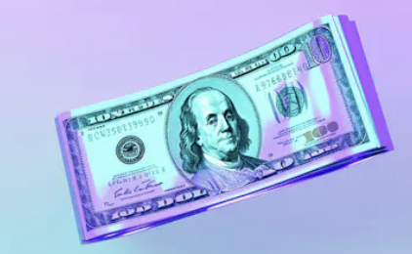

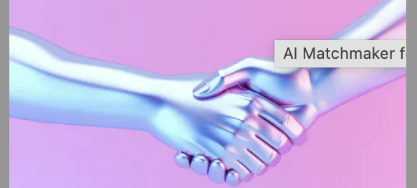

Size 18:

Fonts:
Pacifico
ShesBetter

Lobster
ShesBetter

Style Script
ShesBetter

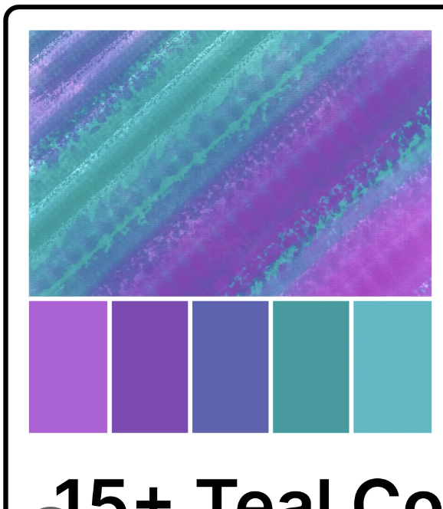

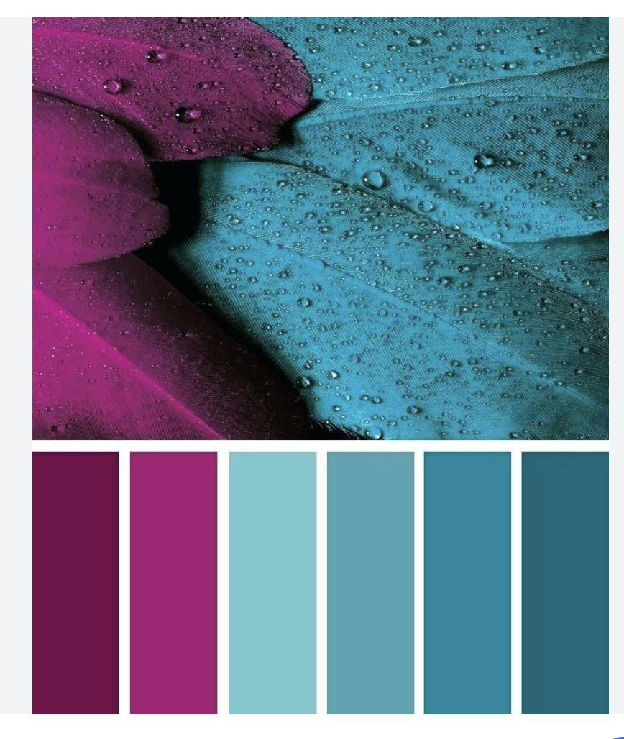

- AppStore Screenshots | 100s of Beautiful Templates
- iPhone Mockups - 3D Snapshots & Animations Generator
- iPhone Mockup: Multi Device Animation Scene
- 3D
- Modern
- Updated
- Colors on brand

